NAMA : Dzaky Eryan Akbar Pramana

NIM : 2300018036

MAPEL : DASAR SISTEM KOMPUTER

KELAS : A

1. GITHUB

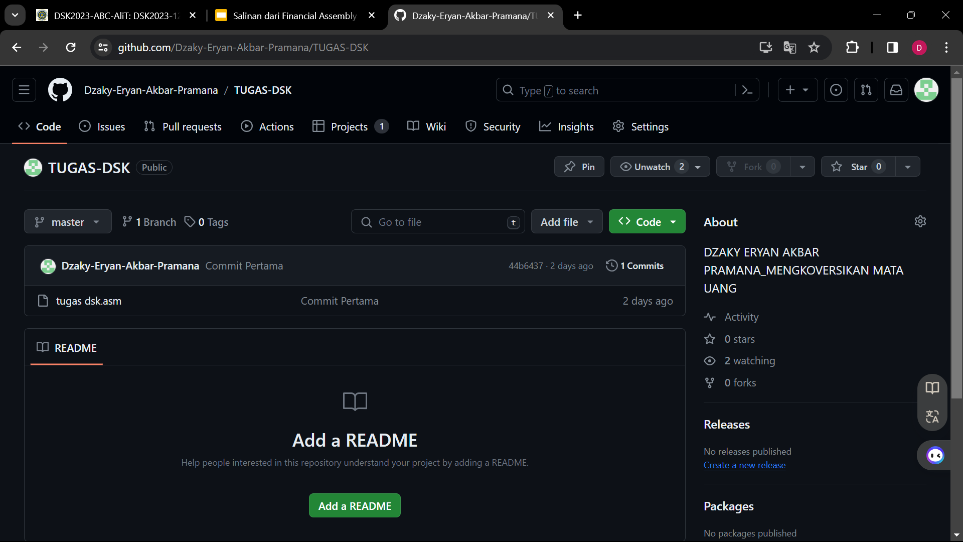

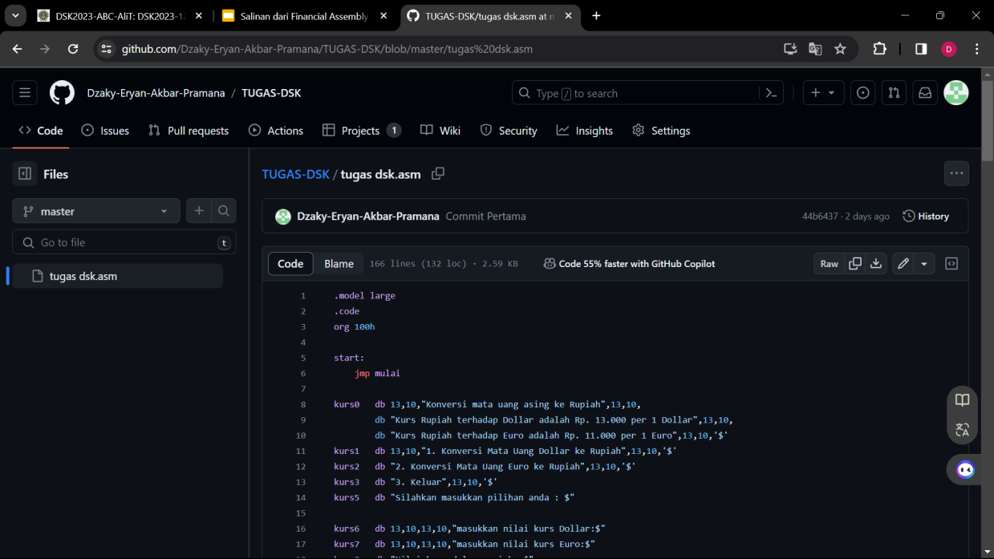

<https://github.com/Dzaky-Eryan-Akbar-Pramana/TUGAS-DSK.git> (Online.text)

1. EMU8086

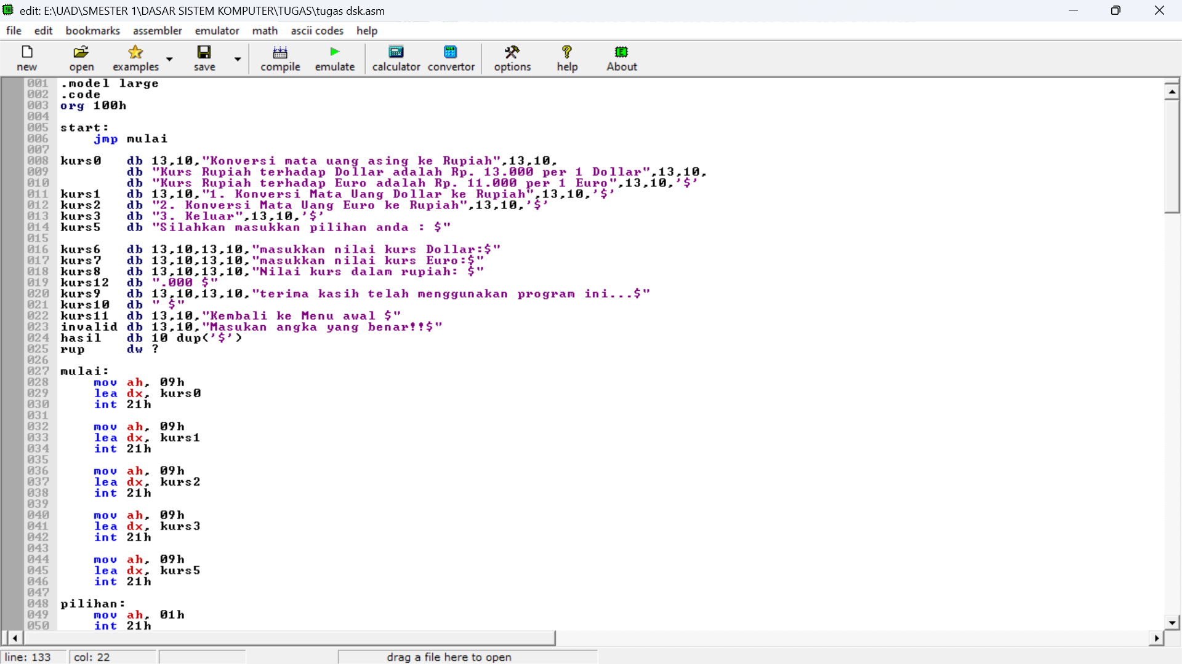

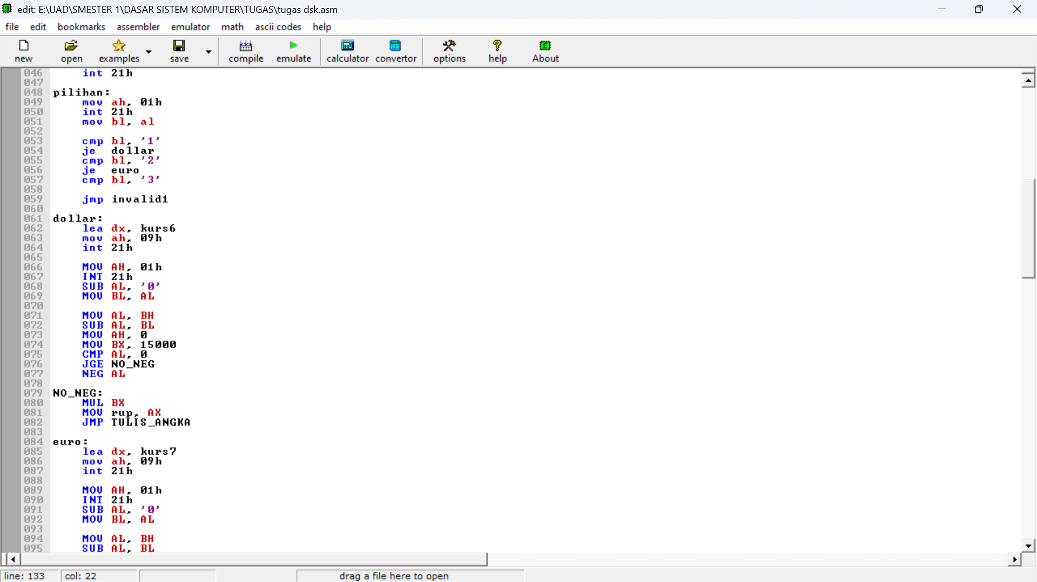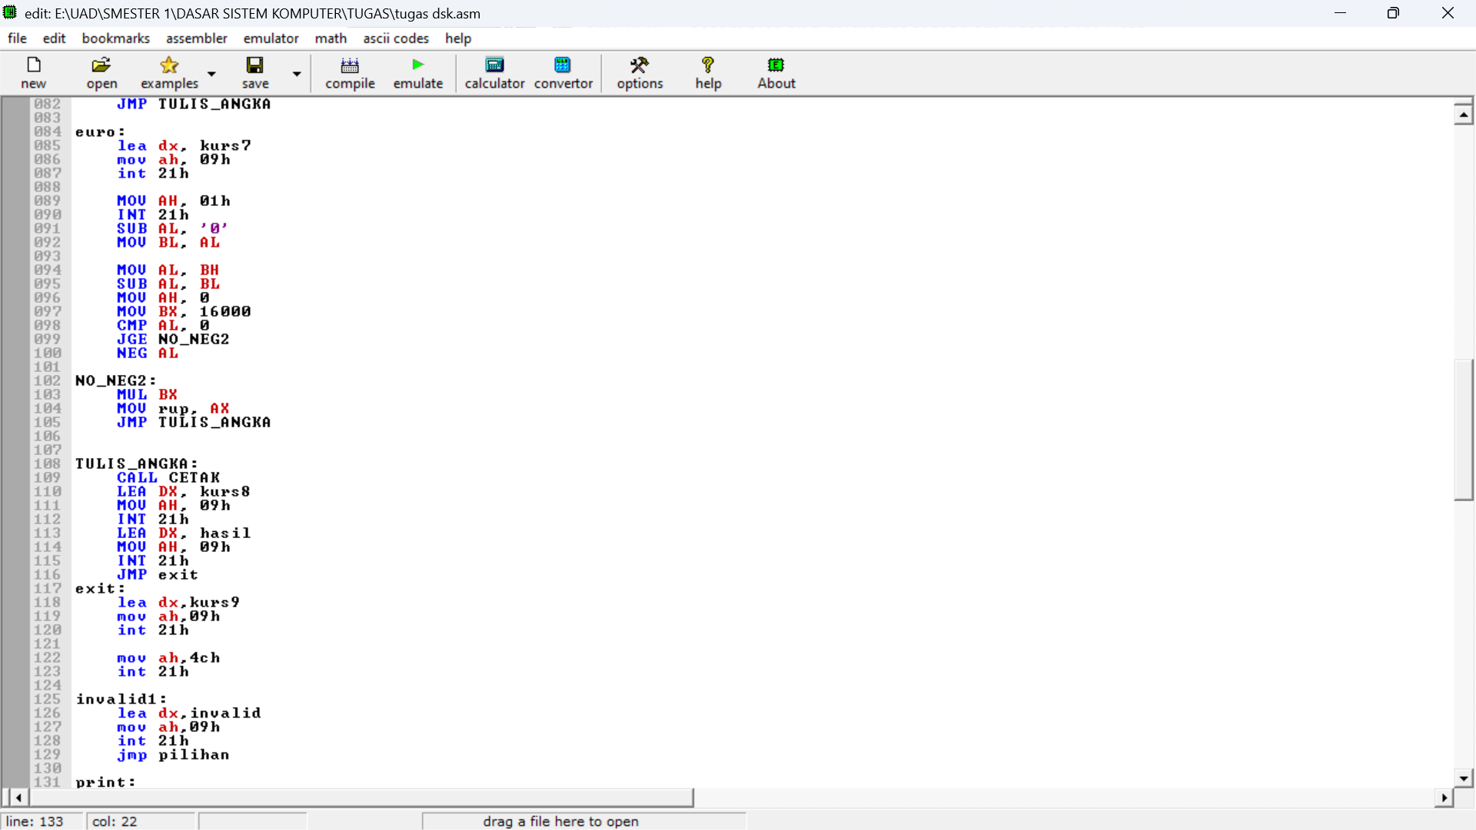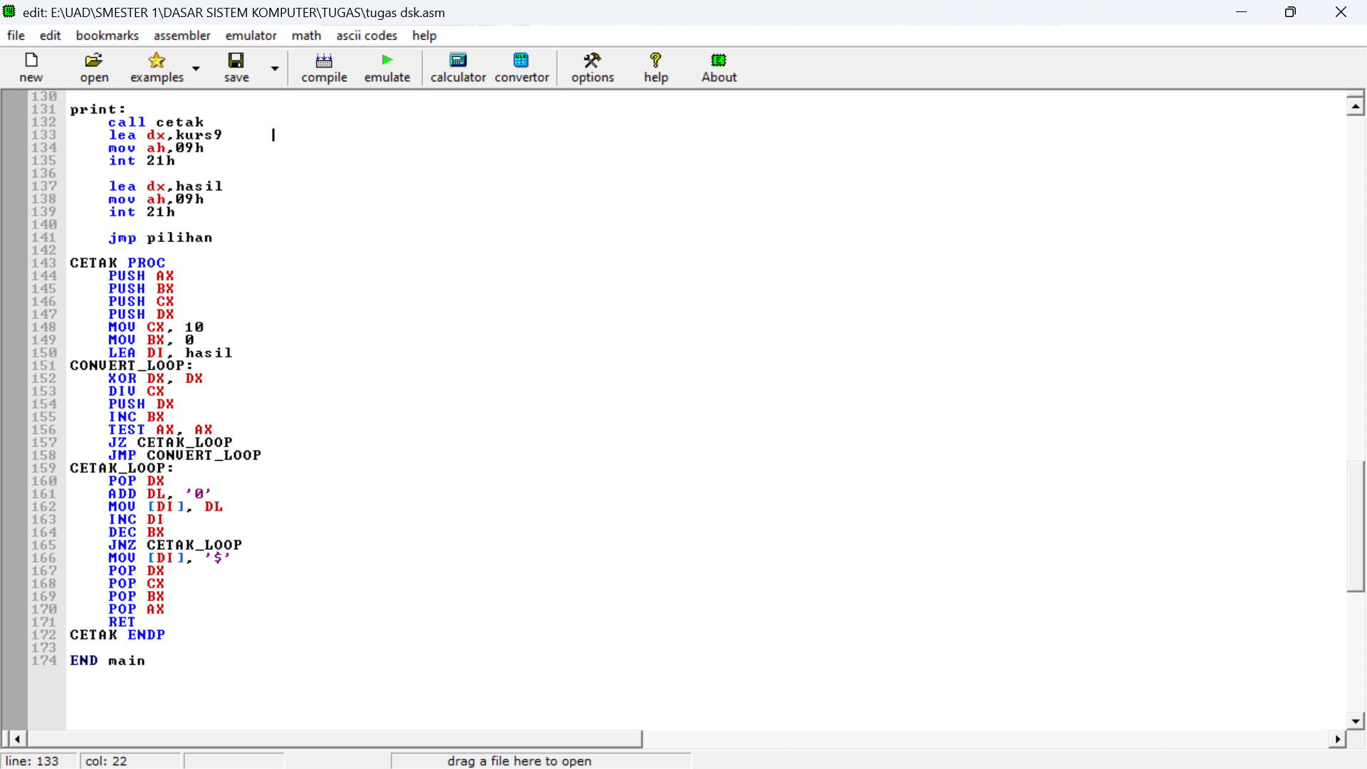

1. YOUTUBE

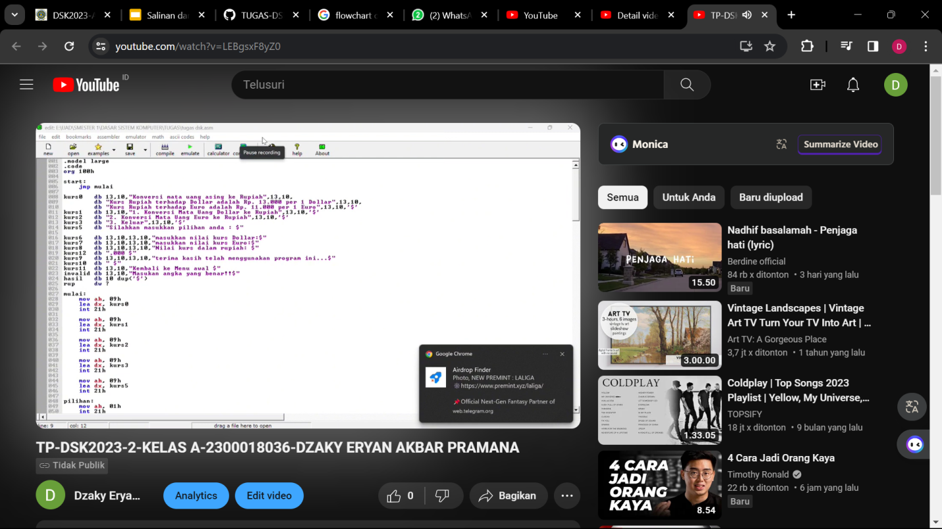

<https://youtu.be/LEBgsxF8yZ0?feature=shared> (online.text)